MOJÁCAR EMBRACES THE WOMEN'S DAY RACE: SPORT, FAMILIES, AND SOLIDARITY
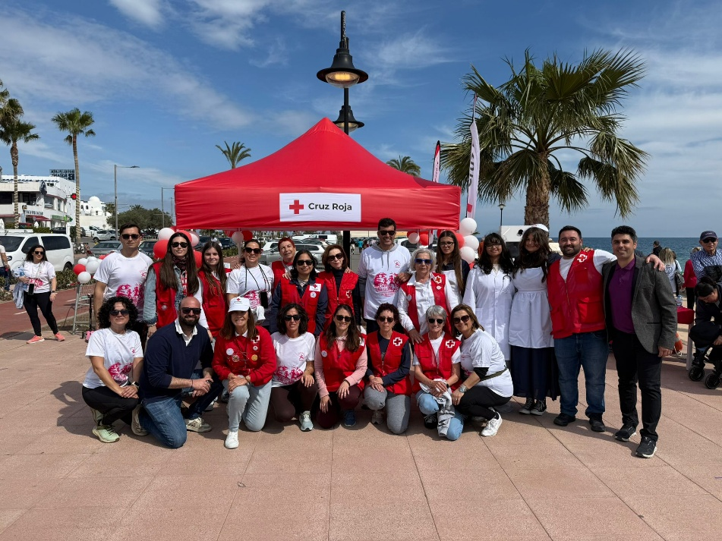
Mojácar celebrated another edition of its Women's Day Race last weekend, an event marked by high participation and a festive, supportive atmosphere. More than 300 people joined in with this sporting and social initiative, which once again brought together residents, families and visitors around equality, sport and solidarity.

The race, organised in collaboration with the Mojácar Red Cross, raised more than 1,110 euros, which will go towards supporting the social work the organisation carries out in the municipality.

The day started early with the Peque Playfest, a space especially designed for young children and their families. Boys and girls enjoyed various educational and recreational activities, such as the Teddy Bear Hospital, where they learned basic first aid and resuscitation skills in a fun way, introducing them to the world of care and healthcare through play.

They also took part in a personalised badge workshop, games, and activities designed to foster creativity, teamwork, and learning while enjoying the race atmosphere.

The event took place in a friendly and participatory environment, with music, entertainment, and a charity photocall that meant those taking part could take home a memento of the day.

The celebration concluded with a paella shared among participants, providing a fitting end to a morning of sport, fun and solidarity.

The organisers expressed their gratitude for the tremendous involvement of everyone who took part in the race, as well as the collaboration of the Mojácar Red Cross, whose participation was key to the success of this charitable event, which, once again, demonstrated Mojácar's commitment to social and community initiatives.

